Motor Cars

Subject:  Related Subjects: | Grade Level(s):  Length of Lesson: | Type: Inquiry / Design / Project  Keywords:

Lesson Overview
Use this section to describe at a high level what the lesson is. Should be no more than 3-4 lines.

Lesson Focus
What is the central question or phenomenon being investigated? What problem are they trying to solve?

Lesson Objective(s) | Students will review the basic components of a circuit and review how switches are used to control electrical systems. They will learn the purpose of a wheel and axle, and be able to distinguish between the different types of energy that go into the movement of the car.

Lesson Timing

5 minutes | Introduce the Lesson
30 minutes | ...

Materials | - Battery holders  - Batteries  - Wires  - Motors  - Switches (NO, NC, SPST, SPDT)  - Wheels  - Wooden dowels (for axle)  - Straws  - Popsicle sticks  - Wire strippers  - Glue guns
Instructor Prep | - Step 1
Related Resources | - List related lessons/ppts etc available from USC or outside, trusted orgs

Lesson Plan

Introduction
After learning about the basic components of a circuit, we’ll use a battery, wire, and motor to build a moving car. The battery contains potential energy, which is like stored energy. Once the car begins to move, it has kinetic energy. The potential energy together with the kinetic energy of the car is called mechanical energy.

We will add wheels and axles to our cars. A wheel and axle works together to move a load when effort is applied. This helps reduce friction in the car, and helps the car move more easily without using as much energy.
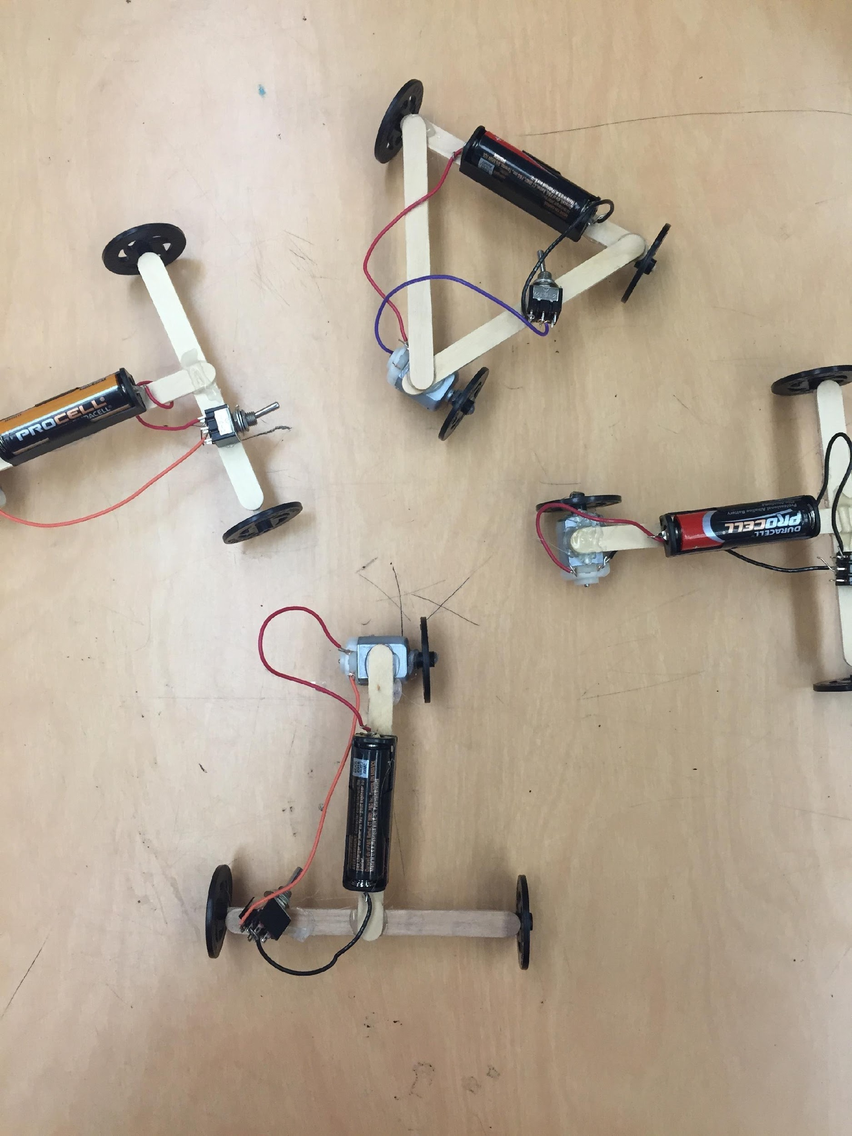
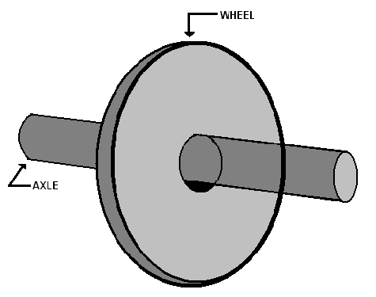
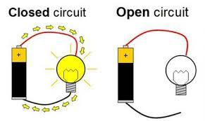

Procedure

- Students will first put together the circuit and its basic parts, connecting the wires to the motor and adding a switch
- After constructing the circuit, they will glue the battery pack down on one of the popsicle sticks.
- Build the wheel and axle by pushing the wooden dowel into the wheel and pushing a straw through the straw.
- Push another wheel into the other end of the wooden dowel and straw.
- Glue the straw part down on the opposite side (underneath) the same popsicle stick the battery holder is glued onto.
- Students can finish constructing their cars based on their own design.

Wrap-up
- Do you know the basic components of a circuit?
- Do you know what a wheel and axle does?
- Do you know the difference between potential and kinetic energy?

Lesson Background for Teachers

Suggested Real-World STEM Connections
- List possible related Role Models in STEM (with details and links to more reading). Give suggestions for examples of scientists/engineers who are from underrepresented groups in STEM in related careers.
- List related real-world engineering problems and examples

Lesson Variations and Options
Include descriptions of alternative methods or ways to present things.

Explanation
Describe the background concepts and explanations behind the lesson. This can be more in depth than a teacher/instructor would actually share with students.

Key Concepts and Vocabulary
- Word 1: Grade Appropriate Definition
- Word 2: Grade Appropriate Definition

Safety Notes
- Safety instruction

